8.70: a) After impact, the block-bullet combination has a total mass of 1.00 kg, and the speed V of the block is found from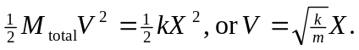The spring constant k is determined from the calibration; 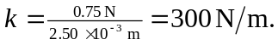 Combining,

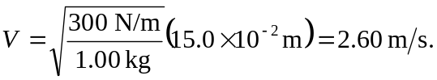
b) Although this is not a pendulum, the analysis of the inelastic collision is the same;

